|  |  |  |
| --- | --- | --- |
|  | **THE ROCK REPORT**  **Marine Corps League Detachment 1306**  Meetings are held at the American Legion Post 40  Federal Furnace Road, Plymouth, MA  Third Tuesday of each month at 1830 (6:30pm)  www.plymouthmarines.com  **September 2025** |  |

**MESSAGE FROM OUR DETACHMENT COMMANDANT**

As I write this, we have approximately 10 weeks left until our Marine Corps birthday ball. A year ago, none of us would ever have imagined that we are where we are now.

It all started when at a meeting early this year with only about 6 members present that Joe Pravati said the words that will live in Detachment 1306 history… “We should have a Ball”.

Since then, we have done fundraisers that were not just a “spaghetti dinner” but that of well-thought-out events. The reenactors added a dimension that brought value to what was done, thank you Nick Eufrazio. The raffles, the cornhole tournament, the breakfast, the car shows are some of the events that we did.

A great thank you to all the members that have worked their butt off to get us closer to our finish line. Joanna, thank you for your endless energy, Joe, thank you for your ideas, Jackie, thank you for your connection to Marine General Mattis. Danielle, thank you for your social media skills. Joe Nutter, thank you for the canopy that most other detachments would be envious of. Willie and Vale, thank you for your generosity. Lucian, thank you for keeping all our finances and paperwork in order, (The Paymaster/Adjutant is the unsung hero who makes or breaks a Detachment.) Butch for keeping us in line and all his behind-the-scenes work that people don’t see. Jon, Past Commandant, thank you for your leadership in past times.  And thank you to all the others that haven’t been mentioned who make up our great Detachment.

**I also want to give credit to Bev and Paul Sullivan who have been a backbone of this Detachment for many years. Thank you for your support. We pray for your good health.**

On Sept 6th, please join us at the end of Holmes Terrace, North Plymouth at the bluffs at 10 AM.  The Marine Corps League Detachment 1306, along with the American Legion Post 40 Color Guard, will participate in a Memorial Service for Staff Sergeant “Scrappy”, a Marine War Dog who sniffed out bombs in Afghanistan saving many lives.

And finally thank you to Plymouth’s American Legion, VFW, Salvation Army and South Coast Cruisers. Without all your support the Ball and Plymouths Marine Corps League itself wouldn’t be happening.

In conclusion, as Joe Pravati said… “We should have a Ball”.

AND WE WILL!!!

Respectfully yours,

Semper Fi,

Jay Beauregard

Commandant, Det. 1306

**Honoring Heroes: A Meaningful Day of Service and Learning**

By Joanna Elizabeth Nelson

On May 15th, I had the honor of participating in a community service-learning project with the 6th grade class from Plymouth South Middle School at Vine Hills and Oak Grove Cemeteries in Plymouth, MA. As part of their project, the students replaced worn and tattered flags at the gravesites of veterans, learning about the individuals who served and the sacrifices they made.

Among those honored were two Congressional Medal of Honor recipients: James B. Chandler, a Union Navy Sailor during the American Civil War, and Samuel C. Wright, who served in the Union Army during the same conflict. I was invited to read the official Medal of Honor citations at each of their gravesites and had the privilege of answering students’ thoughtful questions.

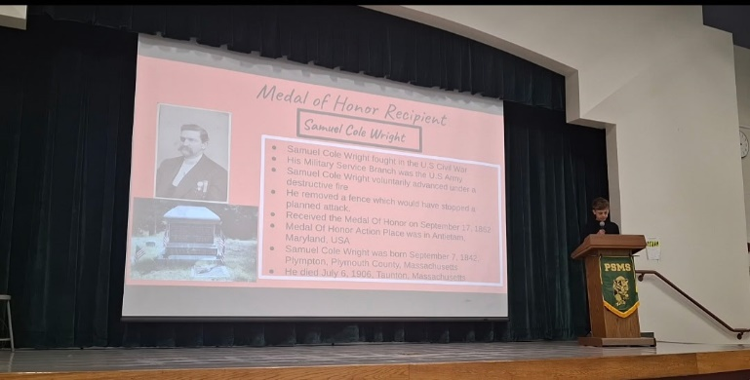

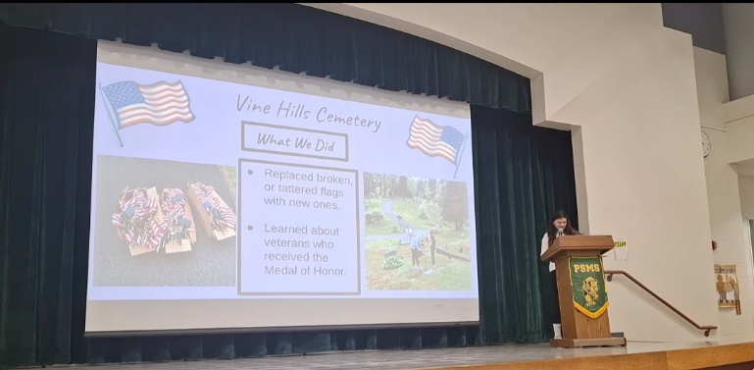

It was truly inspiring to witness the respect and care each student demonstrated while replacing the flags. Their sincere efforts reflected a deep appreciation for the service and history represented at each grave.

On May 21st, I was invited back to the school to view the students’ presentations about their experience. Hearing what they had learned and how the project impacted them was both touching and impressive. They did a wonderful job capturing the significance of their work.

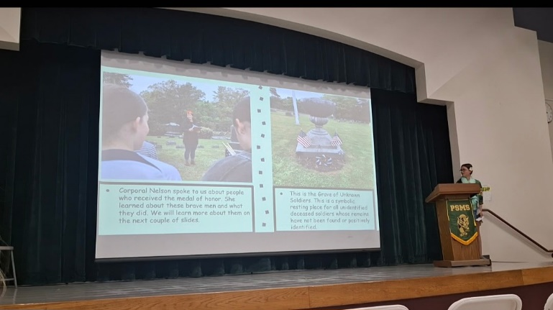

This experience was a powerful reminder of the importance of honoring those who served and of teaching the next generation to do the same with respect, gratitude, and understanding.

**VETERANS DAY IN JULY**

On Saturday July 26, 2025, the Plymouth Detachment of the Marine Corps League in partnership with the Volunteers of America hosted a Veterans Day in July Cornhole Tournament/Cookout at the Plymouth VFW Post. It was during this event that the Detachment put its brand-new canopy to use, thanks to Joseph Nutter and Jay Beauregard.

Other than enjoying the food, music and friendly competition the Detachment raffled several prizes with the proceeds to go towards our upcoming 250th Marine Corps Birthday Ball. Among the raffle prizes were an engraved Japanese Officer’s Sword commemorating the 80th anniversary of the Battle of Okinawa, an engraved era replica of a Mameluke sword commemorating the Marines 220th anniversary of the assault on Tripoli and an engraved Ka-Bar knife commemorating the 50th anniversary of the end of the Vietnam War-THANK YOU to Bryan’s Design. We also raffled off an autographed book from General Mattis and silver coins donated from Paul and Beverly Sullivan.

The American Legion sponsored two teams for the cornhole tournament. Carlos Ulloa and Joseph Rhodes won first place. Butch Raynes and Lucian Pravati competed but didn’t place. Butch got wore our “carrying” Lucian.

There were historical displays set up by Marine veterans who portray Marines and equipment from past eras.

Joseph and Rebecca Nutter brought a pig, a ferret and a tortoise for children to interact with. Rebecca has a business Sunny Brook Menagerie that will bring a petting zoo to a birthday party or other event.

Figure Tilly

The day proved to be a successful fundraiser for our Marine Corps Birthday Ball. The Volunteers of America is a great partner, and we appreciate the support of VFW Post 1822.

**SOUTH COAST CRUISERS**

By Danielle Pizzi

South Coast Cruisers is a new group but not new to the car show world. The key founders are Darren Morey, Tom Tengberg, Jim Dow, Bobby Knight and Rickie Ricardo.

South Coast Cruisers started in May of 2025 and have weekly Saturday events (weather permitting) at Kingston Collection 5PM - 8PM, with vendors, food, entertainment, and an average of 200-300 cars. In just a short time they have over 1,100 followers! They are making this into a festival which will be family-friendly and dog-welcoming.

Adding to their events, monthly they host a new charity and for August generously extended this to the Plymouth Marine Corps League!

Detachment 1306’s experience was indescribable, but I will try. The group of people who attend these events are giving, friendly, embracing, and lovely. Vendors donated items to be raffled: "Liz Artesanal Soap" donated a lovely gift to be raffled a bag of bath salts, soap, scrub, and other self-care items. "Downtime Creations" (Darren Morey) donated a gorgeous tray which was raffled and the winner donated it back for a future raffle! 50/50 winners donated a portion (up to half) of their winnings. This group certainly love their veterans and have big hearts.

Then unexpectantly South Coast Cruisers donated a large sum of $500! We were blown away by their generosity. We were thrilled and would not expect anything more, but wait there is more…

They are leading the charge with a “Wags & Wheels Festival” on Saturday, October 4th from 12PM – 4PM at Shops at Five. It is event benefitting detachment #1306, powered by South Coast Cruisers and Sunny Paws Rescue.  This is also supported by PetSmart!

This is the first organization, who has gone out of their way to fundraise and cultivate awareness for the Plymouth Marine Corps League.  We are truly blessed to have their support.

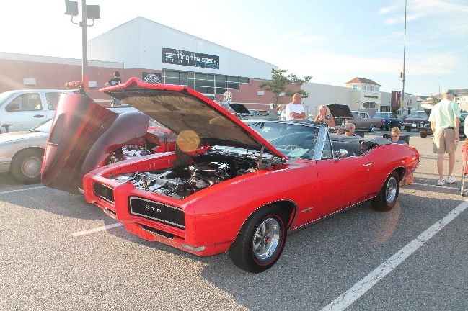

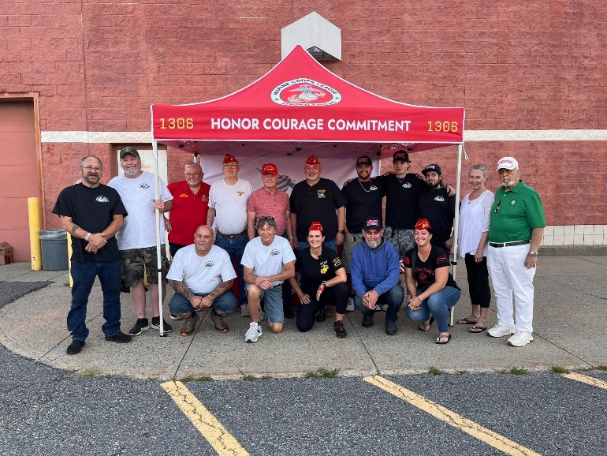

**Member Profile-Senior Past Commandant Jonathan Denham**

By Lucian Pravati

The members of our Detachment meet once a month and share some time with each other; but to me it seemed that we did not really get to know each other and what our experiences were while serving in the Marine Corps. While we all have earned the Eagle, Globe and Anchor, we all took different paths to stand on the yellow footprints. Our members range in age from their 30’s to their 90’s. We served in different eras and experienced different things. The intent of the Member Profile is to help us get to know each other better.

Jon and I met at the Water Street Café on a beautiful late summer Saturday morning. I will say this about Jon from the start; Jon is the proverbial New England Yankee. He grew up in Whitman, MA and graduated from Whitman High School in June 1963. Jon enlisted in the Marines because a close friend had also done so. Jon liked the sound of it from what his friend told him, and he wanted to test himself to see if he could “measure up”.

Jon was interested in aviation and when he was not selected for aviator training he chose to work in aviation electronics. Jon attended his specialty training in Jacksonville, FL after which he was assigned to Marine Fighter Squadron VMFA-542 at El Toro Marine Corps Air Station, California.

Jon was only there for several weeks before VMFA-542 was deployed to mainland Japan prior to operating in Vietnam. Jon worked on electronics in the Phantom F4 aircraft that operated out of Da Nang.

VMFA-542 rotated back to Japan and then returned to Vietnam for another tour. Jon explored Da Nang, swam at China Beach and sang in a band while in country.

Jon and all the Marines of VMFA-542 left the colors of their squadron in Da Nang while other Marines took their place. Jon and his fellow Marines ended up at Marine Corps Air Station Beaufort, SC and became VMFA-314.

Jon left active duty and returned home to Whitman, MA and studied for 4 semesters at UMASS Amherst. I asked him what it was like being a Vietnam Veteran and attending college at the height if the Vietnam War. Jon says that he does not remember any conflict or difficulties that other veterans of that time encountered.

Jon withdrew from college and over the years have worked many…and I mean MANY…different jobs. From stringing wire at the Fore River Shipyard, to building car radios, quality control, working at Household Finance Company, FedEx and then tire sales. Jon is a “people person”. As a Service manager he says that it was his job not to “give bad news” but to advise people as they were a friend.

Jon went to the National Cemetery in Bourne to help replace Flags for Memorial Day when he met some Marine Corps League members, struck up a conversation and decided to join. He served as Senior Vice Commandant and Commandant for our Detachment.

**Recipe from Gunny’s Galley-Devil Dogs in Honor of our 250th**

Contributed by Beverly Sullivan

](https://blogger.googleusercontent.com/img/b/R29vZ2xl/AVvXsEh_pJVAxEE3kQ3PcGybr-tch4C35RDRv1Wu3WqHDQ4E4-DrktO6MebVejBDbgrsqLuwBymJmjnYpj3K4EdJ1oZwwygvM2QKg4Ac5SjZO9Qh5a24w7_ZaFOSdAQENodkV4KF9FklrQYerto/s1600/Teufel_Hunden_US_Marines_recruiting_poster.jpg)

The term **"Devil Dogs"** dates to 1917 or 1918—it is believed the name was coined by Germans to describe American Marines during World War I and alluded to their tenacity. The term was picked up on the home front: the German word for it, ***Teufel Hunden*** was used on Marines recruiting posters in 1918, and newspaper stories also mentioned the phrase that year. The name became firmly associated with the Marines at that time but began being used for the snack eight years later.  
  
Don't want to make the Devil's Food Cake from scratch? Use a Devil Food Cake mix, but be sure and follow the filling recipe.  
  
**HOME-MADE DEVIL DOGS**  
  
**Ingredients**  
  
**Cake**  
1 egg  
1/2 cup unsalted butter, softened  
1 1/4 cup sugar  
1 cup milk  
1 tsp vanilla extract  
2 -1/3 cups all-purpose flour  
1/2 cup Dutch process cocoa  
1/2 tsp salt  
1/2 tsp baking powder  
  
**Filling**  
6 Tbsp unsalted butter, softened  
1 cup confectioners' sugar  
1 7-ounce jar marshmallow creme (1-1/2 cups)  
1 tsp pure vanilla extract  
  
**Directions**  
  
**Cake**  
Preheat oven to 400  
In medium bowl, blend together egg, shortening, sugar with electric mixer. Continue to beat while adding milk and vanilla.  
In another bowl sift together remaining cake ingredients -- flour, cocoa, salt, and baking powder.  
Spoon Tbsp of batter into strips about 4 inches long and 1 inch wide on lightly greased cookie sheet. Bake 5-6 minutes until done. Cool.  
  
**Filling:**  
Put butter in bowl of stand mixer fitted with the whisk attachment and cream until fluffy (about 4 minutes). Add confectioners’ sugar, marshmallow cream, and vanilla and continue mixing on low speed until combined, fluffy and smooth (about 2 minutes). But cream in pastry bag with large tip (or Ziploc bag with corner cut in wide way). Pipe onto cakes as below.  
  
Pipe marshmallow cream over surface to cover, chill for 10 minutes so cream stiffens, then place second cake on top to make sandwich. Repeat with remaining cakes and filling. Cover and chill for at least 1 hour before serving. Will keep in refrigerator (covered) for up to 5 days. It can be frozen for 2 months. Makes a lot of Devil Dogs!

**250th Marine Corps Ball Tickets**

Marines! It is time to purchase your tickets for the Detachment’s first Marine Corps Ball. Please buy your tickets as soon as possible. We need to know the number of attendees so that the Ball Committee can finalize the planning and order certain items in time. All are welcome. Marine, soldier, sailor, airman or civilian. Tickets are available at [www.plymouthmarines.com](http://www.plymouthmarines.com) or use the QR code below.

